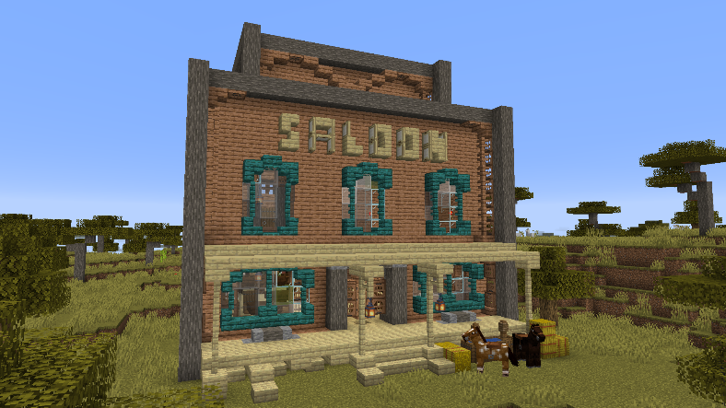

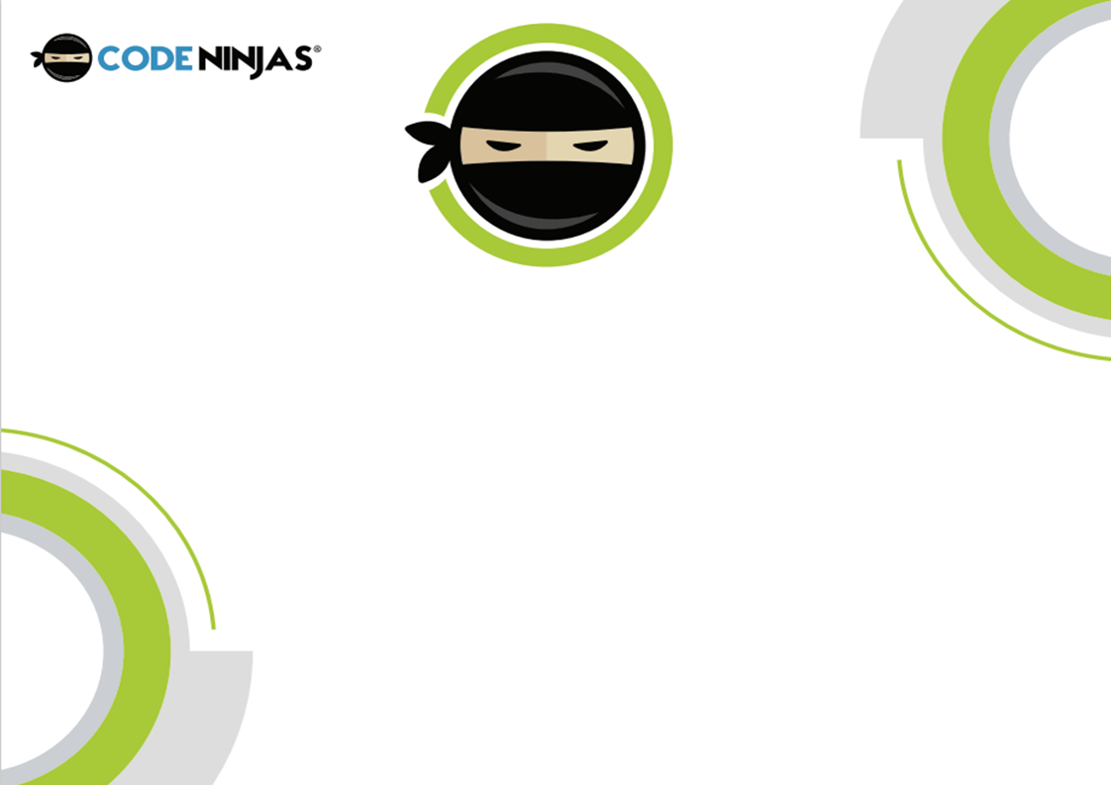

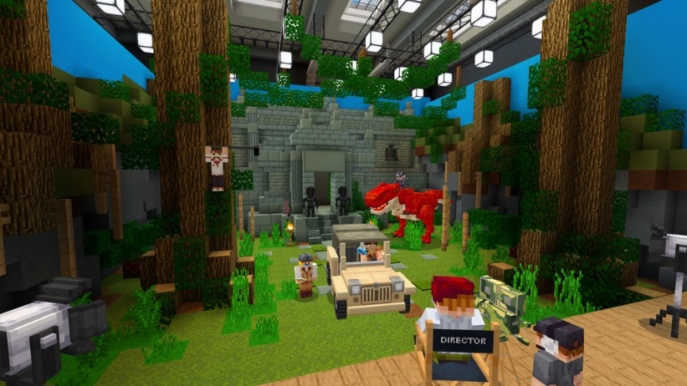



What good is a story without a place to tell it!? Today +CHILDNAME+ kicked off +hisher+ session creating the set of their recording!

Since getting to grips with our replay editor, +CHILDNAME+ has learned how to move around the camera in space and time to allow for professional looking transitions and camera movements without too much complexity. Now +CHILDNAME+ has to plan out and build their set for their story they will be telling. For some Ninjas, the story is the building of the set itself, for example a story of a stranded survivor building a shelter to live in, so the recording would need lots of smaller sections cut together in a montage of the creation over time.

For most Ninjas the story will take place in their set, for example a tavern brawl in the local Western Saloon! For both types of story, planning is key. To avoid having to go back to the drawing board and restasting the creations, it is essential that we plan the creations with +CHILDNAME+ so +heshe+ has a clear goal of what their final story’s set will look like. After making the plan of the set and stroy, +CHILDNAME+ got to work!

Many Ninjas are somewhat used to creating in Minecraft, but not many have planned their creations before making them! This helps develop +CHILDNAME+’s creative skills and shows +himher+ how useful planning can be to creating projects. Taking inspiration from other Ninjas is something we always recommend and foster in our Dojo, having +CHILDNAME+ stand up and walk around other Ninjas creations having them each share what they have made to others!

Brilliant work +CHILDNAME+! Very well done for planning, creating and sharing your set today!

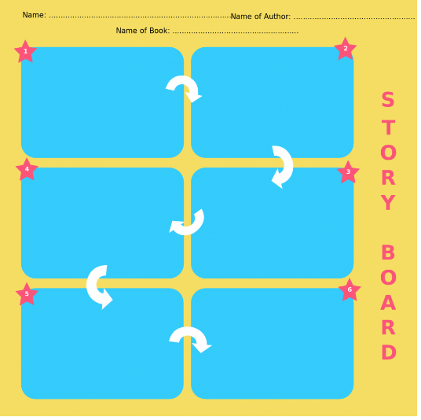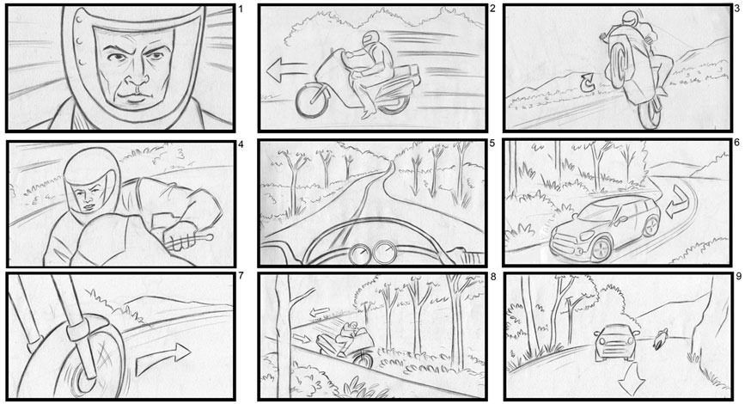





+CHILDNAME+ jumped into their storytelling with a very vital part of the process today!

After having an amazingly creative time with adventure maps, playing with filming/editing software and creating +hisher+ own set. We now have to pivot and begin thinking about the planning that occurs behind great imaginative projects.

When writers in various fields want to make ideas easily understood, they choose a storyboard format! Just like most children +CHILDNAME+ seemed to love this session with a larger graphic focus and when +heshe+ got to organise all those awesome ideas into one great story, they loved it even more! +CHILDNAME+ was naturally attracted to drawing things up in this storyboarding stage with our hands on drawing as after all, it takes some practise to compile their creativity into one flow.

Another important lesson that we learnt here is that this also helped +CHILDNAME+ organize their ideas and present them in an orderly manner. We added some colourful and eye-catching examples to help along the way to bringing this epic tale to life!